
YEAR 12 CHEMISTRY – ATCHE

Volumetric Analysis Practical Test

Recommended time: 55 minutes

Name:
Total marks

/ 40

Teacher:

Titration as a Quantitative Chemical Analysis Technique

Determining the composition of a solution is an important analytical and forensic technique.
Sodium carbonate, Na₂CO₃ is an important industrial chemical as it is used in a number of applications including water treatment, general cleaning, descaling and buffer solutions.
Commercial sodium carbonate has a purity of > 98 %. Major impurities in sodium carbonate include sodium chloride. The purity of commercial sodium carbonate depends on the composition of the raw materials, the production process and the intended use of the product.

One common method of measuring the amount of pure sodium carbonate in an impure sodium carbonate mixture is mass percent (or percentage by mass) where

% by mass of Na₂CO₃ = m (pure Na₂CO₃) / m (impure Na₂CO₃ mixture) x 100

The aim of this investigation is to use knowledge of acid-base reactions and titration technique to accurately determine the amount of pure sodium carbonate in a sodium carbonate/sodium chloride (Na₂CO₃/NaCl) mixture and hence calculate the percentage by mass of sodium carbonate in the sample provided.

Procedure:

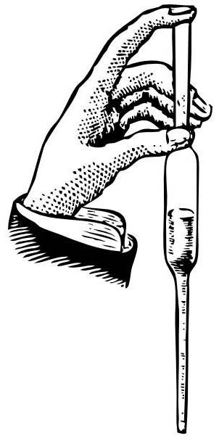
- Use a pipette or buretta to transfer a 20.0 mL aliquot of the sodium carbonate/ sodium chloride solution mixture into ONE of the conical flasks given.


2 During the session your supervisor will come around and observe your technique in using the buretta. Please make sure you have been seen and ask if you have not!.

1 mark for correct use, 1 mark accurate top reading, 1 mark accurate bottom reading
3

3 Titrate the 20.0 ml aliquot of sodium carbonate/sodium chloride solution mixture (conical flask) against the standardised hydrochloric acid solution from the burette by selecting ONE of the two indicators provided.

Put up your hand and ask your supervisor to assess the colour at the end point.
3

(3 marks for 1st attempt, 1 mark for 2nd attempt, 0 thereafter)

4 Repeat Steps 1 and 3 until you obtain consistent results.
3
Burette Reading

Titration | 1 | 2 | 3
Final Volume (V₂) | Correct use of table (1 mark)
Initial Volume (V₁)

Titration Volume (mL)  (ΔV) = V₂ - V₁ | Must have at least 2 concordant titre volumes (2 marks)
2
Average Titration Volume = ________ mL

Correctly calculated & 2 decimal places answer (2 marks)

5 Write a balanced IONIC chemical equation for the titration reaction between HCl and Na₂CO₃ in the
space provided below. Include in your equation the correct states of matter.
2
2H⁺_{(aq)} + CO₃²⁻_{(aq)} → CO_{2 (g)} + H₂O_{(l)} (2 marks for ionic or 1 mark for non-ionic and
correctly balanced.1 mark for ionic and not balanced)

Additional information from the whiteboard

Concentration of standardised HCl = 0.10665 mol L⁻¹

6 Calculation:

Use your titration results and additional information from the whiteboard to calculate the percentage by mass of Na₂CO₃ in the Na₂CO₃/NaCl mixture.

Marks for Steps 1-3 are awarded for correct procedures and sufficient working shown. Correct final numerical answer is not important.

- n(HCl) = c (HCl).V_{AV} = 0.10665 x V_{Av} = mol (1 mark)

- n(Na₂CO₃) in 20.0 mL mixture = 0.5 x n(HCl) = mol (1 mark)

3. m(Na₂CO₃) in 20.0 mL mixture = x 105.99 = g (1 mark)

m(Na₂CO₃) in 20.0 mL mixture / m(mixture in 20.0 mL) x 100 = / 0.113g x 100 (1 mark)
4
Final Answer

% by mass of Na₂CO₃ to three (3) significant figures = 74.9%

_{Accuracy} | ₀ | ₁ | ₂ | ₃

Answer in 3 s.f. (1 mark)

Answer within (70% - 80%) (2 marks)

Answer between (60% - 90% ) (1 mark)

Other answers (0)

* Note: Follow-through marks awarded if student used an incorrect mass of mixture for calculation in Step 4*.
above i.e. Students use m(mixture) in 1L (as per whiteboard) for calculation instead of m(mixture) in 20.0 mL.
Volumetric Analysis – Written Section (20 marks)

Name: _____________________________________________________ (1 mark each)

Teacher: _____________________________________________________

In each of the following, write the correct name, formula, number or descriptive term that best match the description.

1 | A name given to a solution of exactly known concentration that can be obtained highly pure with a known formula and high molecular mass. | Primary standard
2 | ONE (1) example of a substance that satisfies the conditions listed in Question 1. | Na₂CO_{3,} H₂C₂O₄, NaHCO₃
3 | A name given to glass equipment used to accurately deliver a fixed volume of solution. | Pipette
4 | Name of glass equipment that must not be pre-rinsed with the solution to be added to it. | Conical flask
5 | The level of accuracy to which final and initial volumes should be read from the burette. | 2 decimal places, or +/- 0.05mL
6 | A name given to the volume difference between the initial volume of and the final volume of titration. | Titration volume or titre
7 | Name of a substance that can be added to the reaction mixture in the conical flask without affecting the outcome of the titration. | Distilled water or indicator
8 | Give an example of a SYSTEMATIC error that could occur in this experiment.  Specific examples should be given (eg Burette scale). Also hot day affecting celebration of vol. flask etc | Calebration of any equip’t used.
9 | Name of an indicator that should be used in the titration between ethanoic acid and sodium hydroxide. | Phenolphthalein
10 | 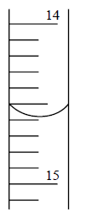  The reading (to the correct number of significant figures)  shown on the burette opposite is: | 14.58  Accept  14.57 - 14.59

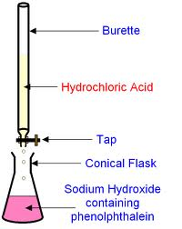
The following questions refers to the following titration:

Ethanoic acid

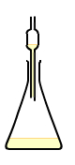

Pipette or
Buretta

For this experiment, state the correct final rinsing solution for each of the following glassware:

11 | Burette | Ethanoic acid
12 | Pipette | Sodium hydroxide
13 | Conical flask | Water

Questions 15-18 refer to the use of indicators in the titration above.

14 | State the change in the colour of phenolphthalein indicator as the titration proceeds. | From pink to faint pink /colourless
15 | State the pH of the reaction mixture at the equivalence point. | Greater than 7
16 | State the change in indicator colour if methyl orange was used instead of phenolphthalein. | From yellow to orange/red
17 | State the pH at the end point of methyl orange indicator. | 3.1 - 4.4 or any numbers in between.

State the effect of the following acts on the volume of ethanoic acid used to achieve the equivalence point in the titration above. Write your answer as more acid is needed, less acid is needed or no effect.

18 | Distilled water was used as the final rinse for the burette. | More acid is needed
19 | Sodium hydroxide was used as the final rinse for the conical flask. | More acid is needed
20 | Methyl orange was used as the indicator. | No effect (nasty!)  OR More acid

